Approver Guide (New UI)
This document provides a condensed overview of approval process. It will demonstrate with short text descriptions supported by screen shots for each step explained.
New users of this system are encouraged to contact Office of Procurement Management, Lisa Hubbard, 605-773-4580, lisa.hubbard@state.sd.us, for proper training in approving requisitions/transactions.
Current users are welcome in contacting Lisa if you have questions in approving requisitions/transactions with the new update. Most of the information has been moved from the left side to the right side of the screen with extra information being viewable.

Table of Contents
  - Approving a Transaction
  - Rejecting a Transaction
  - Tracking Progress with View Workflow
  - Prepare CC
  - Release PO
  - View Order
  - Re-Release

Approving a Transaction
The approver reviews the transaction under the Approve Tab. Approvers can locate specific transactions through the following search options:
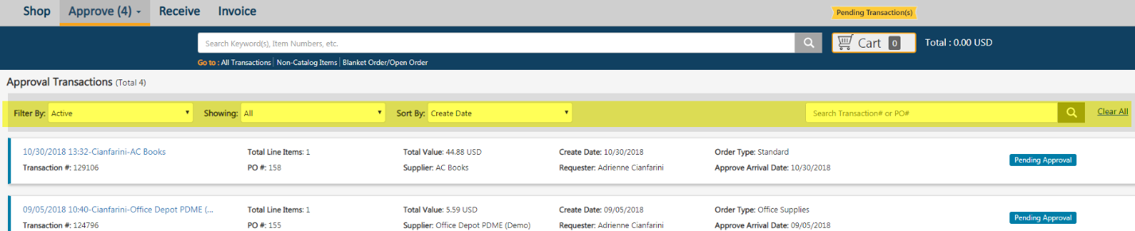
    - Filter by Status
      - Note: The Selection “Active” indicates the current user’s action is required. Waiting indicates that another user or General Ledger action is required.
    - Date Range based off of the arrival to the Approve Tab.
    - Sort by Account #, Arrival date, Create Date, Order Type, Payment Form, PO #, Requester Name, Transaction #, Transaction Name, Status, and Supplier (A-Z)/(Z-A)
    - Search by Specific PO or Transaction Number
    - Clear all to restore searching to default

Select the Transaction Name to review the order.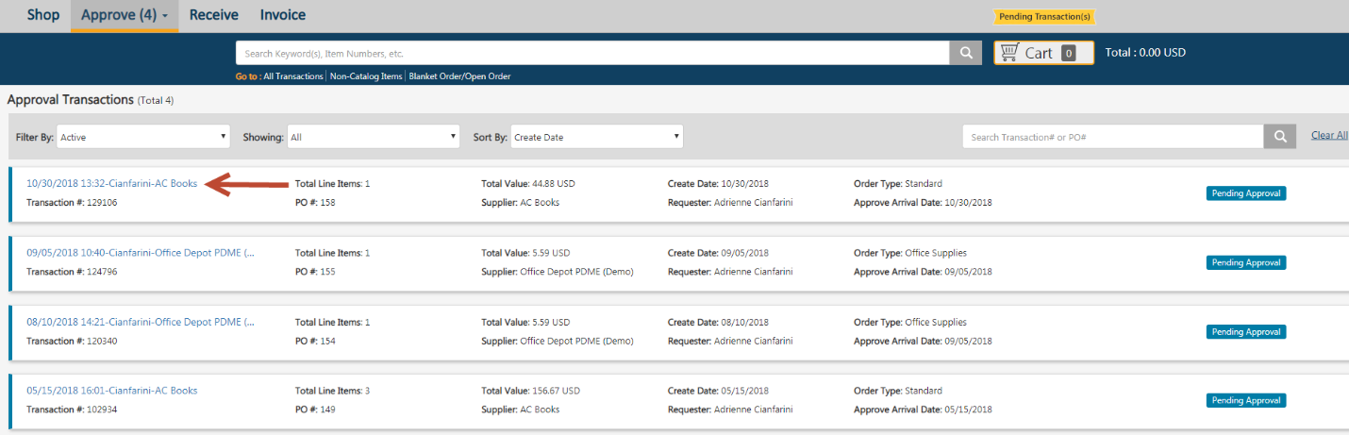
The approver can review the information that the originator specified, and also add or edit internal (users) and external (suppliers) notes. Approvers can Hold (Pause) or Archive (Permanently freezes Transaction and saves the record for Auditing) by selecting the appropriate icon in the upper-right corner of the screen. Approvers can review details of the transaction by selecting each section header. Things an Approver should review for accuracy per the criteria’s listed below:
Punchout Catalogs – Innovative, Fastenal, Grainger and Staple
(the steps below do not apply for CDW and Riverside Technologies (RTI) Punchout Catalogs. See Computer Purchases & Punchout Catalogs – CDW & Riverside Technologies (RTI) for the proper steps).
Release Method should be Electronic
Approval Workflow should be Agency Workflow
NIGP Code for Innovative - Office Supplies should be 615; the other punchout catalogs, just select a code that comes closes to what you are purchasing.
Purchase Order # will be the Fiscal Year, followed with a P, for Purchase, and the Transaction Number…example 20PXXXXXX.
Direct Voucher/Credit Card Purchases under $4000 (that are not Punchout Catalogs)
Release Method should be Manual
Approval Workflow should be Agency Workflow
Purchase Order # will be the Fiscal Year, followed with a P, for Purchase, and the Transaction Number…example 20PXXXXXX.
Encumbrance Purchases under $4000 (use this when you want to have the purchase written to the state’s accounting system and processed as a purchase order).
Release Method should be Manual
Approval Workflow should be Encumbrance to OPM
Purchase Order # will be the Transaction Number
GL Acct. Code will need to be active in the state’s accounting system and ESM.
Computer Purchases & Punchout Catalogs – CDW & Riverside Technologies (RTI) under $4000
Release Method should be Manual
Approval Workflow should be Encumbrance to OPM
NIGP Code must be 204
Purchase Order # will be the Transaction Number
GL Acct. Code will need to be active in the state’s accounting system and ESM.
Purchases $4000 and over, including Computer Hardware & Software & Punchout Catalogs- CDW & Riverside Technologies (RTI) (these purchases will be written to the state’s accounting system and processed as a purchase order).
Release Method should be Manual
Approval Workflow should be Agency Workflow
Purchase Order # will be the Transaction Number
GL Acct. Code will need to be active in the state’s accounting system and ESM.
Note: Notes and Attachments included in transaction that can be Internal (Users) or External (Suppliers)
External Note: External Note is information or instructions to the vendor. This information will be printed on the purchase order.
Internal Note: Internal Note is information that can be viewed only by the State Agency and Office of Procurement Management. Information you may want to provide is who the item is for or any other information you may find pertinent to the requisition.
Once reviewed, approvers can select the Approve action button at the bottom of the screen.
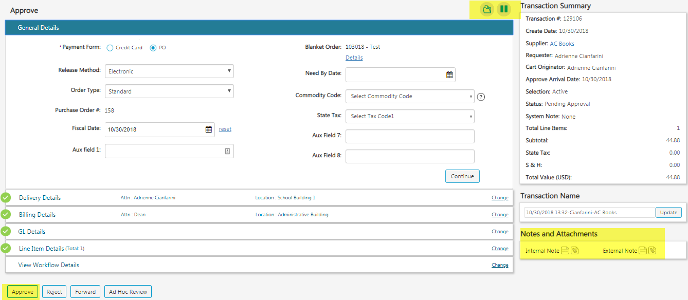
Rejecting a Transaction
The approver can reject the transaction by selecting the Reject button and entering a rejection reason. The transaction will return to the originator for editing.

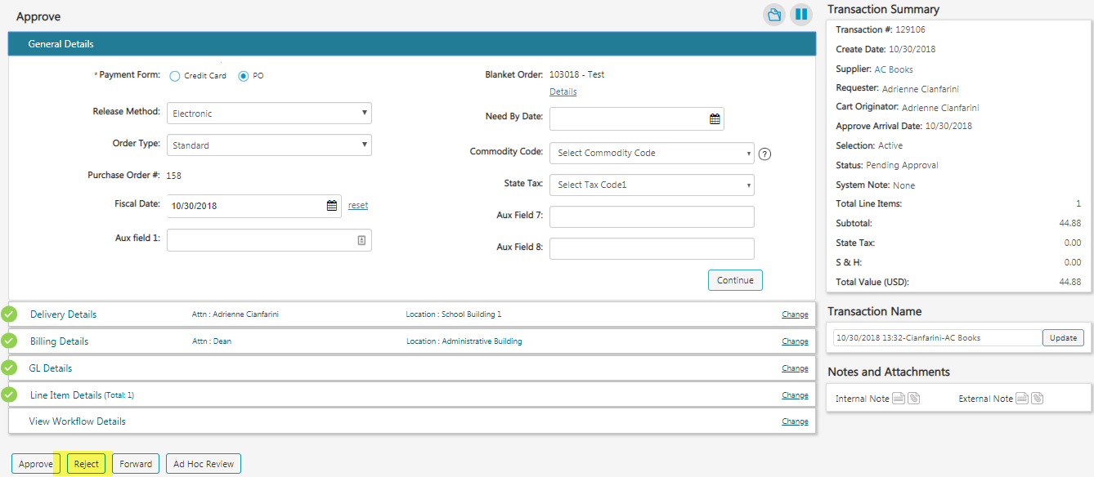

Tracking Progress with View Workflow
Users can view the transaction’s progress in the approval process by selecting All Transactions to locate the order and opening the View Workflow Details section (if sent for approval, it will automatically be the opened section).
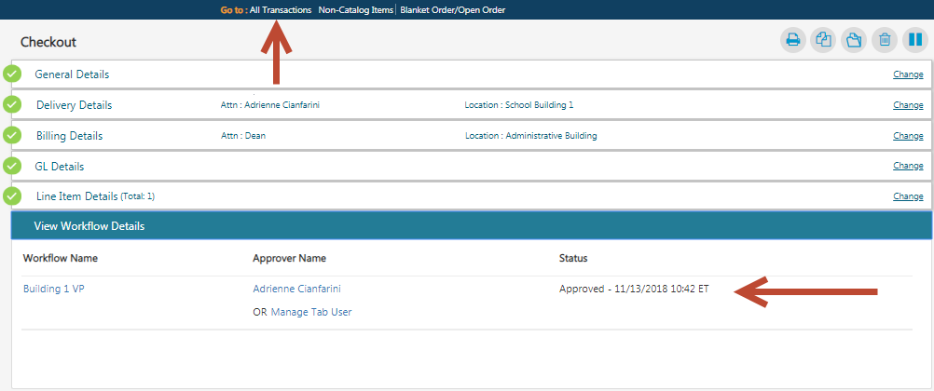
Approver Status:
Active - Transaction is under the user’s approve tab since the date provided
Pending - User has not yet received the transaction, which is still active under the previous approver
Approved - User approved the transaction on the date provided
Hold - User paused the transaction’s approval process under his/her approve tab
Rejected - Approver rejected the transaction on the date provided
If an entity is configured for the final approver to release transactions to the supplier, the requester will receive an email notification when the release occurs.

View Order
The user may select the View Order icon under the All Transactions/Approve/Manage screen.
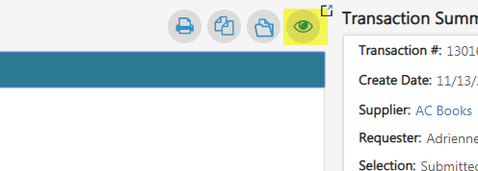

The System Note History states the time the order was successfully released.
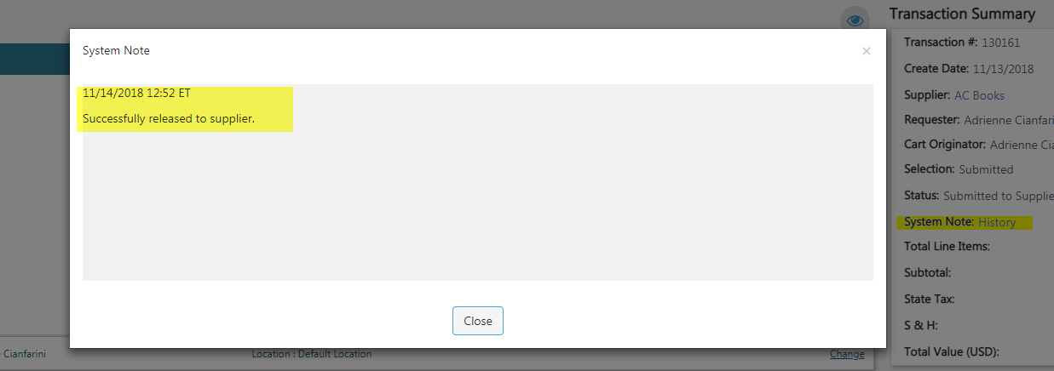

Re-Release Order
Locate the order using the Filter By Option or the Search bar and select the Transaction Name to open the order.
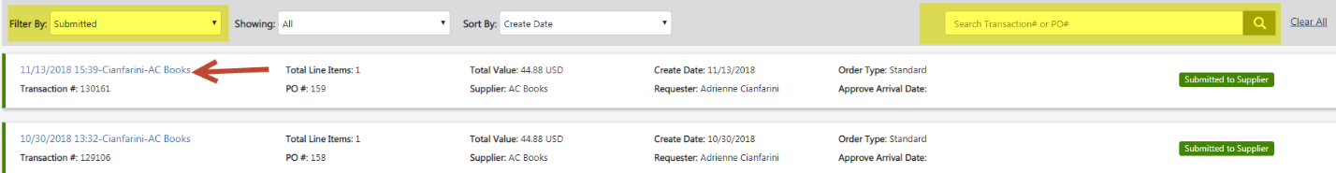

Select Re-Release Order.
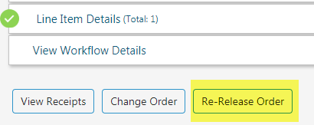

Select Place Order and confirm based on payment type. If the Payment Form is Credit Card and it was declined, provide new card information. Select Continue and Place Order.
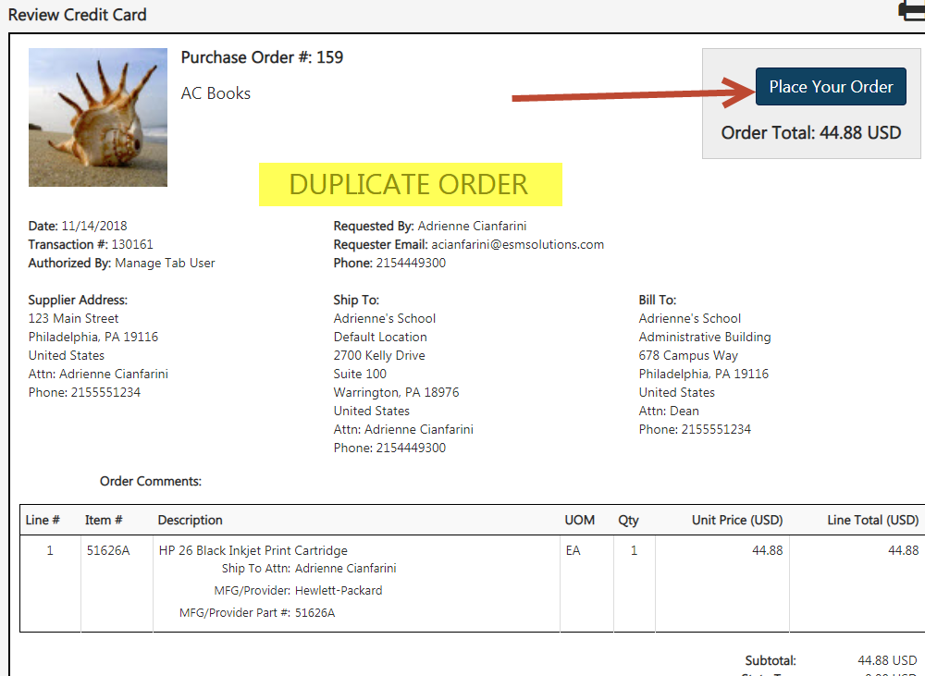
Note: Re-released orders will state “Duplicate Order.”

